Benny the Bug
Once there was a planet far out in space. It was called Bug planet. Benny the Bug lived there, with his mam, dad, friends and thousands of other bugs.
There was another planet next to Bug planet. This planet was called Bird planet. There was always a war between the two planets because the birds that lived on Bird planet loved to eat the bugs on Bug planet. Then it happened: the birds on Bird planet swooped in out of nowhere, on to Bug planet. All the birds were vicious and so fast. There were too many birds, so Benny’s mum and dad brought Benny to an escape pod.
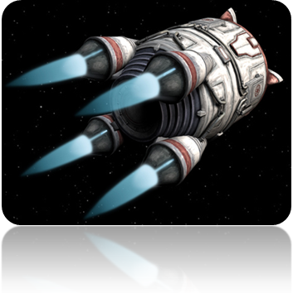
They put Benny in the escape pod, they closed the mini door in the escape pod. Then they launched the escape pod to Earth. The escape pod was hurtling to Earth, with Benny inside it.
The escape pod crash landed in a big field. Benny got out of the escape pod and looked around. He saw a big sign, it read ‘Scoil na Mainistreach.’
Scoil na Mainistreach

Scoil na Mainistreach
Benny turned around, he saw a Bug Hotel. He scuttled over to the Bug Hotel. Benny saw lots of other bugs, they all welcomed him. The other bugs shouted out and said “Will you stay with us? We like you!” “Yes, I will stay with you” replied Benny. He had great fun there but he was sad that his mam, dad and friends weren’t there with him. Suddenly, his mam, dad and friends crash landed in escape pods next to Benny. Benny was delighted to see everyone! They all lived happily ever after in the Bug Hotel!
The End
