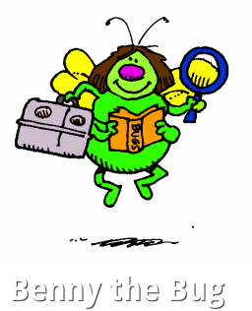 By: Luis Allen
Hi everyone, as you can see my name is Benny the Bug.
This is my story, I used to live with all my family on a very warm island in the middle of the ocean. I had the best job in the world, I was a chief “ Leaf Taster ” . One day I was happy and very full tasting yummy leaves when a big storm came and blew me high up into the sky. I wasn’t really scared until huge greedy Mr. Crow caught the leaf and tried to eat me!! Oh no, then I was scared. I shouted for my Mam or Dad but nobody could hear me because Mr. Crow kept on flying higher and higher away from my home. I was so tired that I fell fast asleep and when I woke up I was freezing cold so I knew I was in a new place. Then I saw all these curious eyes looking at me, I didn’t feel scared because they looked very kind. The eyes belonged to the cool boys and teachers from Scoil na Mainistreach in Celbridge, Co. Kildare and they told me that Mr. Crow was about to eat me again! Luckily I fell off the leaf and landed in their Bug Hotel.
The boys told Mr. Crow about me and that I was sad because I missed my family so he flew back to my island and brought all my family out on a big huge leaf to live happily with me in the very comfy
SCOIL NA MAINISTREACH BUG HOTEL, where the boys and teachers really take care of us.
That’s it everyone and of course we are all living Happily Ever After!!
The End…….

